COURSE LEARNING WEBSITE

USER MANUAL

CEN 4010 - U01

04/04/16

By:

Daylin Gonzalez

Nicolas Perez

Dhrumel Shah

**CONTENTS**

|  |  |  |
| --- | --- | --- |
| **1**. | **Guest** | **4** |
| 1.1. | Create Account . . . . . . . . . . . . . . . . . . . . . . . . . . . . . . . . . . . . | 4 |
| 1.2. | Search Course Material . . . . . . . . . . . . . . . . . . . . . . . . . . . . | 6 |
| 1.3. | Log In . . . . . . . . . . . . . . . . . . . . . . . . . . . . . . . . . . . . . . . . . . . . . | 7 |
| 1.4. | View Course Material . . . . . . . . . . . . . . . . . . . . . . . . . . . . . . | 9 |
| 1.5. | View Discussion Board . . . . . . . . . . . . . . . . . . . . . . . . . . . . | 10 |
| **2**. | **Member** | **12** |
| 2.1. | Add Course Material . . . . . . . . . . . . . . . . . . . . . . . . . . . . . . . | 12 |
| 2.2. | Add Tags to Course Material . . . . . . . . . . . . . . . . . . . . . . . | 14 |
| 2.3. | Rate Course Material . . . . . . . . . . . . . . . . . . . . . . . . . . . . . . | 16 |
| 2.4. | Add Discussion Post . . . . . . . . . . . . . . . . . . . . . . . . . . . . . . . | 17 |
| 2.5. | Add Course to Favorites . . . . . . . . . . . . . . . . . . . . . . . . . . . | 18 |
| 2.6. | View Favorite Courses . . . . . . . . . . . . . . . . . . . . . . . . . . . . . | 20 |
| 2.7. | Remove Course From Favorites . . . . . . . . . . . . . . . . . . . . | 21 |
| 2.8. | Delete Account . . . . . . . . . . . . . . . . . . . . . . . . . . . . . . . . . . . . | 22 |
| 2.9. | Log Out . . . . . . . . . . . . . . . . . . . . . . . . . . . . . . . . . . . . . . . . . . . | 23 |
| **3**. | **Admin** | **24** |
| 3.1. | Delete User . . . . . . . . . . . . . . . . . . . . . . . . . . . . . . . . . . . . . . . . | 24 |
| 3.2. | Upgrade Member . . . . . . . . . . . . . . . . . . . . . . . . . . . . . . . . . . | 25 |
| 3.3. | Degrade Admin . . . . . . . . . . . . . . . . . . . . . . . . . . . . . . . . . . . . | 26 |
| 3.4. | Add Course . . . . . . . . . . . . . . . . . . . . . . . . . . . . . . . . . . . . . . . . | 27 |
| 3.5. | Delete Course . . . . . . . . . . . . . . . . . . . . . . . . . . . . . . . . . . . . . | 28 |
| 3.6. | Delete Course Material . . . . . . . . . . . . . . . . . . . . . . . . . . . . | 29 |
| 3.7. | Remove Tag . . . . . . . . . . . . . . . . . . . . . . . . . . . . . . . . . . . . . . . | 30 |
| 3.8. | Delete Discussion Post . . . . . . . . . . . . . . . . . . . . . . . . . . . . . | 31 |

**OVERVIEW**

The Course Learning Website creates a shared online learning experience for its users. It contains a list of courses and each course has its own page for course materials and a discussion board. Users can access and upload course materials and also post on the discussion board. A course material also has tags so that the user can search for course materials by entering the course name or a tag name. A tag is simply a name or a keyword associated with each course material that allows an easier way for users to search for course materials. Each course material also has a user rating. A user can add courses to a favorite list in order to gain easy access.

The website allows access to 3 types of users: Guest, Member and Admin. The tasks that can be performed by each type of user are listed in the Contents page. Note that a Member also has all the privileges of a Guest, and an Admin has all the privileges of a Guest and Member as well.

1. **Guest**
   1. Create Account
      1. Click on the Register menu item:

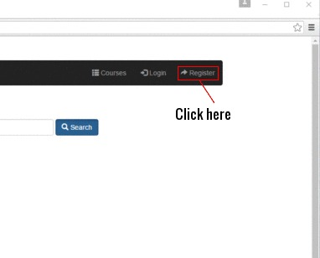

* + 1. A dialog box will appear allowing you to enter your details:

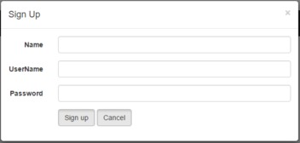

* + 1. Enter your information and then click on Sign Up:

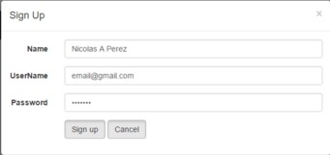

* + 1. You are now a Member. You will be signed in and re-directed to the homepage.

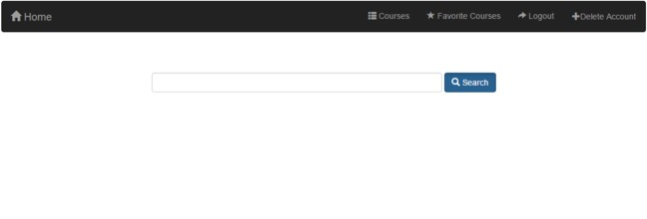

* 1. Search Course Material
     1. In the homepage, enter the name of the Course or Tag in the text box shown. Click on Search after entering the details:

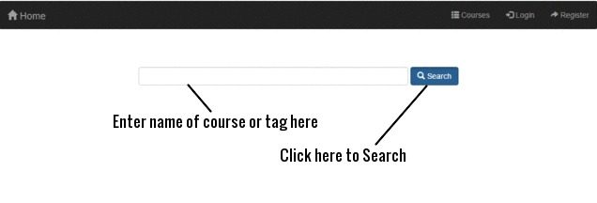

* + 1. You will be re-directed to a new webpage containing a list of matching Course Materials followed by a list of matching Courses:

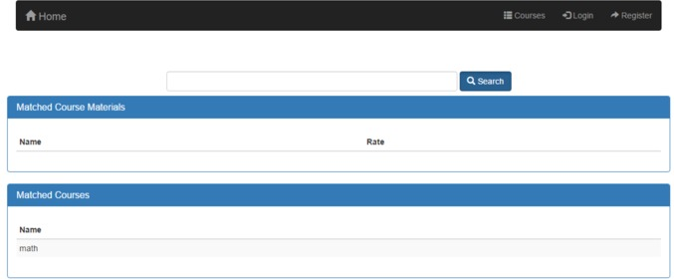

* 1. Log In
     1. Click on the Login menu item:

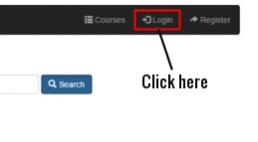

* + 1. A dialog box will appear allowing you to enter your details:

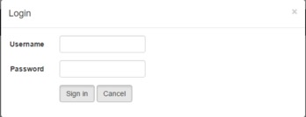

* + 1. Enter your information and then click on Sign In:

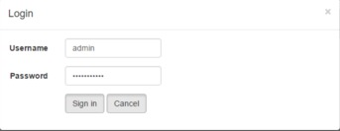

* + 1. You will be signed in and re-directed to the homepage:



* 1. View Course Material
     1. Follow the instructions in the Search Course Material use case to arrive at the following page, then click on the Course Material you want to view:



* + 1. After clicking on the Course Material you want to view, you will be re-directed to a webpage containing the Course Material information:

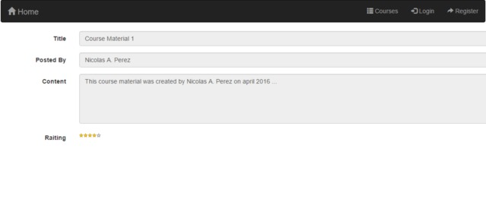

* 1. View Discussion Board

Option 1:

* + - 1. In the homepage, enter the name of the Course in the text box shown. Click on Search after entering the details:



* + - 1. You will be re-directed to a new webpage containing a list of matching Course Materials followed by a list of matching Courses. Click on the Course name associated with the Discussion Board you want to view:



Option 2:

* + - 1. Click on the Courses menu item:

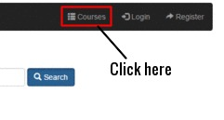

* + - 1. You will be re-directed to a new webpage containing a list of all Courses. Click on the Course name associated with the Discussion Board you want to view:

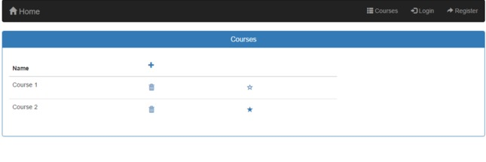

On choosing either option:

* + 1. You will be re-directed to a new webpage containing a list of Course Materials and the Discussion Board associated with the Course:

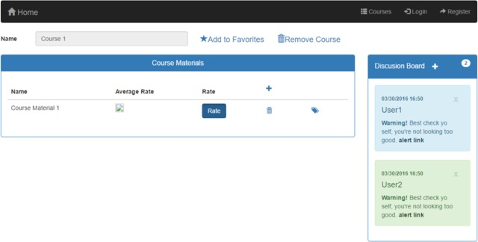

1. **Member**

2.1. Add Course Material

* + 1. Follow the instructions in the View Discussion Board use case to arrive at the Course page:

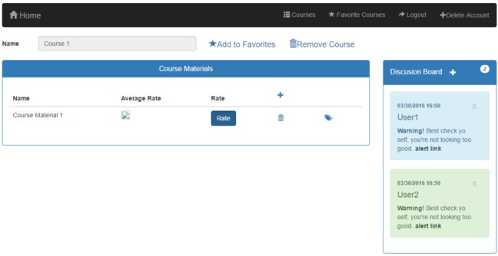

* + 1. Click on the + symbol in the Course Materials section to add a Course Material:

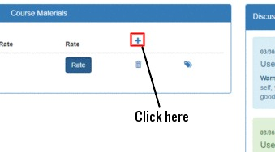

* + 1. A dialog box will appear allowing you to enter the Course Material details. Click on Save after entering the details:

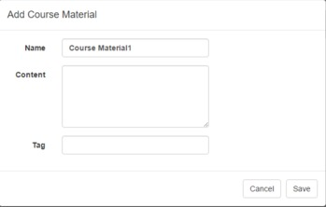

* + 1. The Course Material will be saved and it will appear in the Course Materials section on the Course page:



* 1. Add Tags to Course Material

Option 1:

* + - 1. When adding a Course Material as shown in the Add Course Material use case, enter the tag names in the Tag section, leaving a blank space between each Tag, and click on Save after you are done:

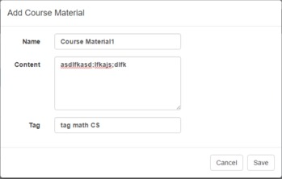

Option 2:

* + - 1. Follow the instructions in the View Discussion Board use case to arrive at the Course page for the Course Material you want to tag. Click on the Tags icon for the Course Material you want to tag as shown:

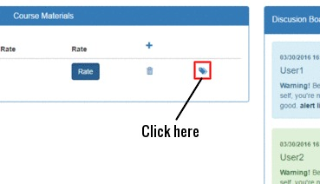

* + - 1. A dialog box will appear. Enter the tag names in the Tag section, leaving a blank space between each tag, and click on Save after you are done:

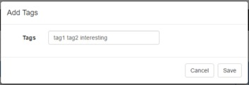

On choosing either option:

* + 1. The Tags will be saved and the Course page will be displayed:



* 1. Rate Course Material
     1. Follow the instructions in the View Discussion Board use case to arrive at the Course page of the Course Material you want to rate. Click on Rate in the section of the Course Material you want to rate:

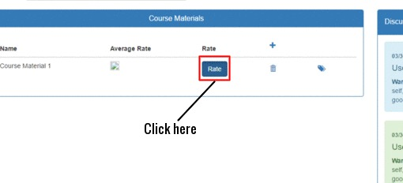

* + 1. Add a rating number (integer from 1 to 5) in the Rate section and click Save:

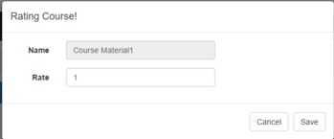

* + 1. The rating will be saved, the Course page will be displayed and the Average Rate will be updated:



* 1. Add Discussion Post
     1. Follow instructions in the View Discussion Board use case to arrive at the course page. Click on the + symbol in the Discussion Board to Add Discussion Post:

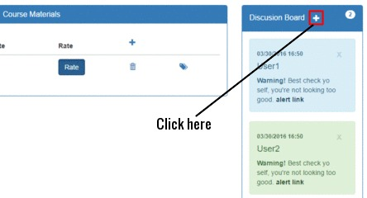

* + 1. A dialog box will appear. Enter your post in the Content section and click Save:

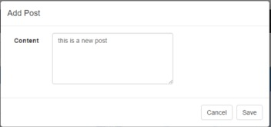

* + 1. Your post will be added to the Discussion Board along with your username, date and time of post:



* 1. Add Course to Favorites

Option 1:

* + - 1. Click on the Courses menu item:

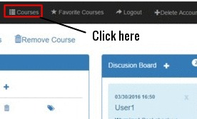

* + - 1. You will be re-directed to a new webpage containing a list of all courses. Click on the star icon in the section of the course you want to add to favorites. The Course will be added to your Favorites list:

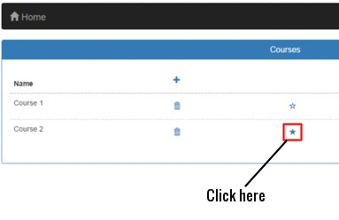

Option 2:

* + - 1. Follow the instructions in the View Discussion Board use case to arrive at the course page. Click on the Add to Favorites star symbol. The Course will be added to your Favorites list:

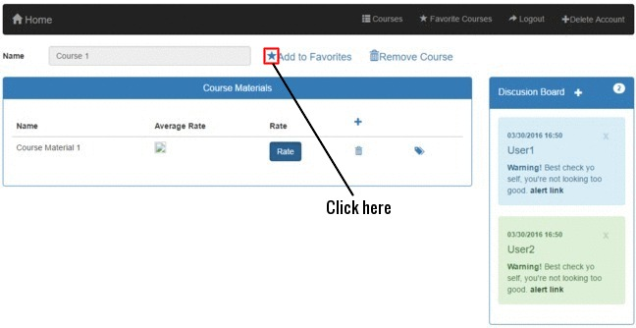

* 1. View Favorite Courses
     1. Click on the Favorite Courses menu item to view your favorite courses:

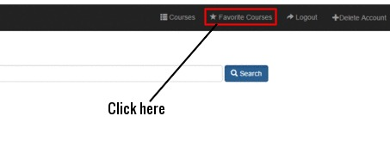

* + 1. You will be re-directed to a webpage containing a list of your favorite courses. Note that initially, all courses will have the star icon highlighted:

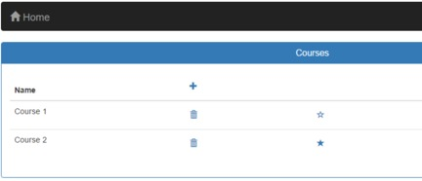

* 1. Remove Course From Favorites
     1. Follow instructions in the View Favorite Courses use case to view the list of your favorite courses. Click on the highlighted star icon in the section of the course you want to remove from your favorites list:



* 1. Delete Account
     1. Click on the Delete Account menu item:

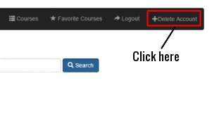

* + 1. A dialog box will appear. Click on Confirm to delete your account:

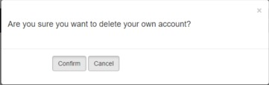

2.9. Log Out

* + 1. Click on the Log Out menu item:

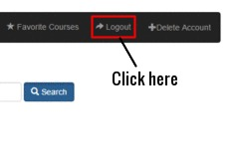

* + 1. A dialog box will appear. Click on Logout to log out of the system:

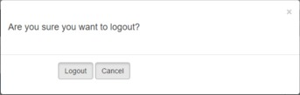

1. **Admin**

3.1. Delete User

* + 1. Click on the Delete User menu item:

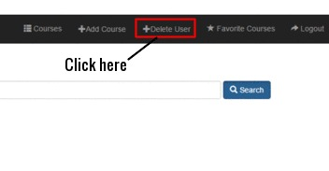

* + 1. You are re-directed to a webpage containing the list of users. Click on the Trash Icon located in the section of the user you want to delete. The user will then be deleted:

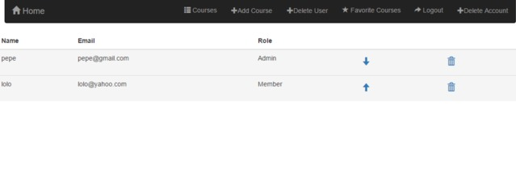

* 1. Upgrade Member
     1. Follow instructions in the Delete User use case to navigate to the user list. Click on the upward pointing arrow icon in the section of the member you want to upgrade:



* + 1. A dialog box appears. Click on Yes in order to Confirm the member upgrade:

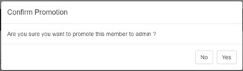

3.3. Degrade Admin

* + 1. Follow instructions in the Delete User use case to navigate to the user list. Click on the downward pointing arrow icon in the section of the admin you want to degrade:



* + 1. A dialog box appears. Click on Yes in order to Confirm the admin degrade:

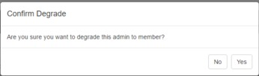

* 1. Add Course
     1. Click on the Add Course menu item:

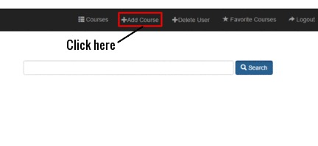

* + 1. A dialog box will appear. Enter the name of the Course you want to add and click on Save. The Course is then added:

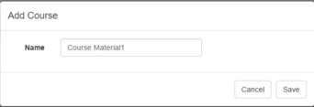

* 1. Delete Course
     1. Follow the instructions in the View Discussion Board use case to navigate to the Course page of the Course you want to delete. Click on the Trash icon labeled Remove Course:

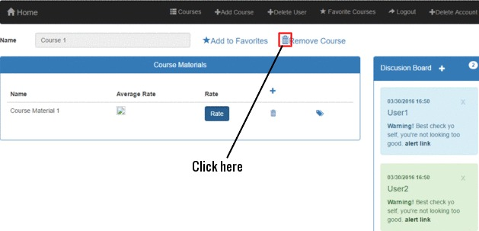

* + 1. A dialog box will appear. Click on Yes to confirm the Course Deletion:

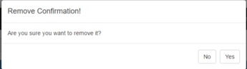

3.6. Delete Course Material

3.6.1. Follow the instructions in the View Discussion Board use case to navigate to the Course page of the Course Material you want to delete. Click on the Trash icon in the section of that Course Material:

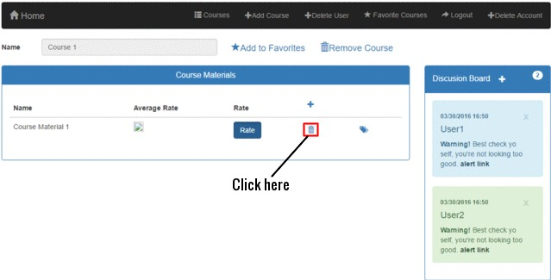

3.6.2. A dialog box will appear. Click on Yes to confirm the Course Material Deletion:

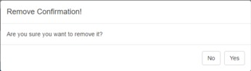

3.7. Remove Tag

3.7.1. Follow the instructions in the View Discussion Board use case to navigate to the Course page of the Course Material whose tag you want to remove. Click on the Tag icon in the section of that Course Material:

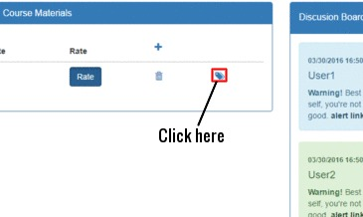

3.7.2. A dialog box will appear. Delete the names of the tags you want to remove:

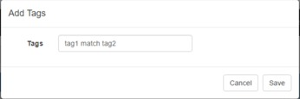

3.7.3. On deleting the tag names, click Save to remove those tags:

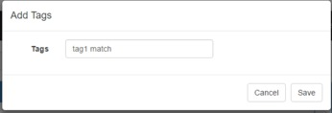

3.8. Delete Discussion Post

3.8.1. Follow the instructions in the View Discussion Board use case to navigate to the Course page of the Discussion Post you want to remove. Click on the x icon in the Discussion Post:

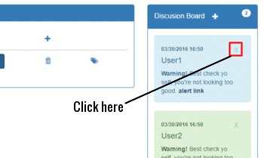

3.8.2. A dialog box will appear. Click on Yes to confirm the Discussion Post Deletion:

